EXP 15

**Create a Cloning of a VM and Test it by loading the Previous Version/Cloned VM**

STEP 1:To create a new virtual machine tap the create new virtual machine

STEP 2: And the next process is to be the guest operating installation

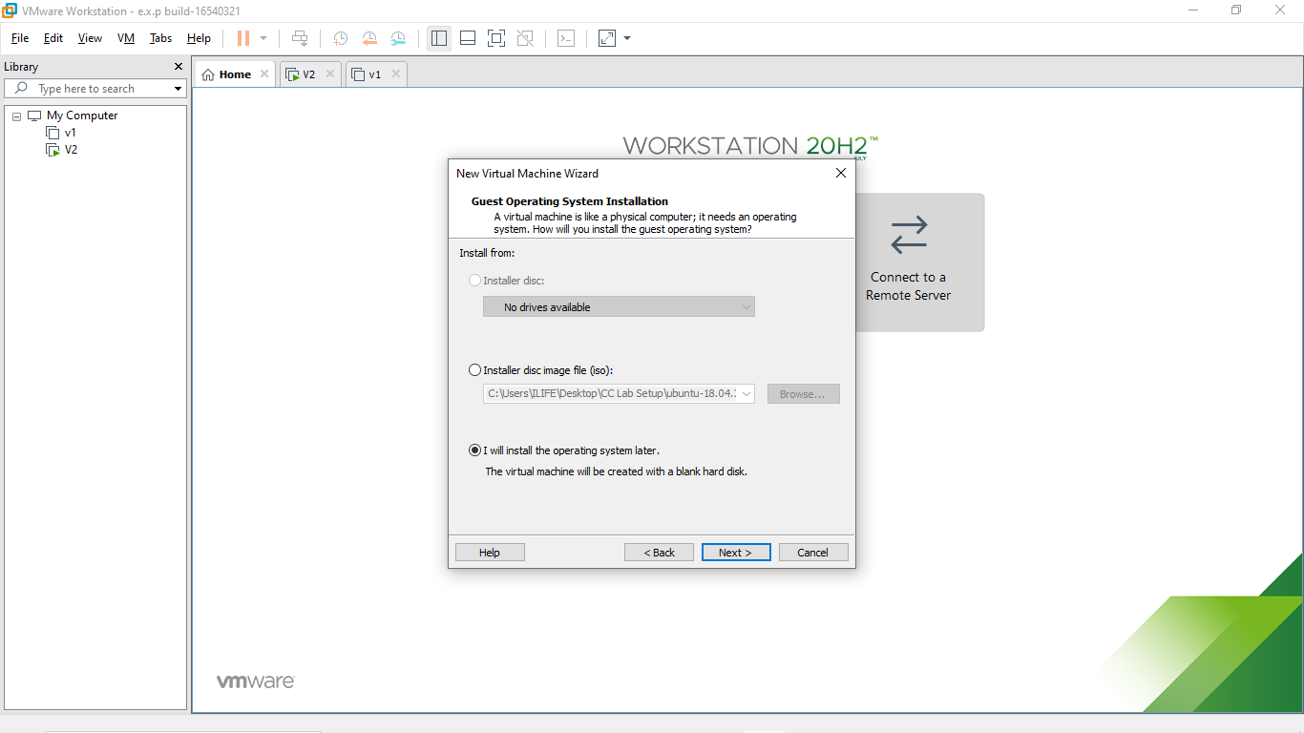

R.Akash 192121091

STEP 3: Select the guest operating system

STEP 4: Name the virtual machine

R.Akash 192121091

STEP 5: Specify the disk capacity and store a virtual machine as a single file

STEP 6: Read to crate virtual machine and click the finish button

R.Akash 192121091

STEP 7: created the new virtual machine

STEP 8: Go to the VM and manage the clone

R.Akash 192121091

STEP 9:Manage the clone from the current state in the virtual machine

STEP 10: The clone of the virtual machine is created

